Haaga-Helia: Back End Programming

Course demos can found from the GitHub:
https://github.com/Haaga-Helia-SOF003AS3A/backend-programming

How to run demos

- Clone the repository to your computer
  - Open the PowerShell (Windows) or terminal (Mac, Linux)
  - Navigate to the folder where you want to clone demos
  - Type command
git clone https://github.com/Haaga-Helia-SOF003AS3A/backend-programming

- Open Eclipse and import one of the demo projects.
  - Select File -> Import -> Maven -> Existing Maven Project
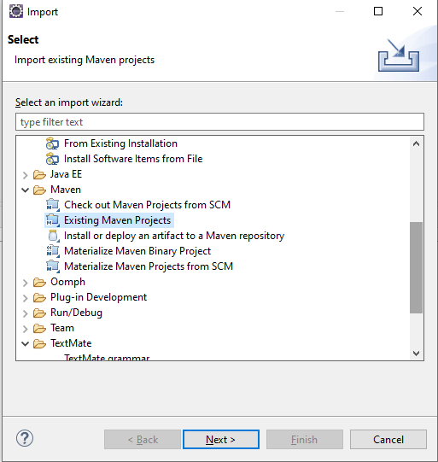

  - Press ’Next’ button
  - Press ’Browse’ button
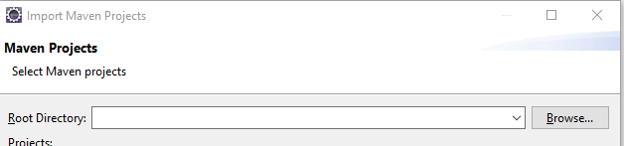
  - Select HelloForm project from the cloned backend-programming folder (click ‘Select Folder’ button)
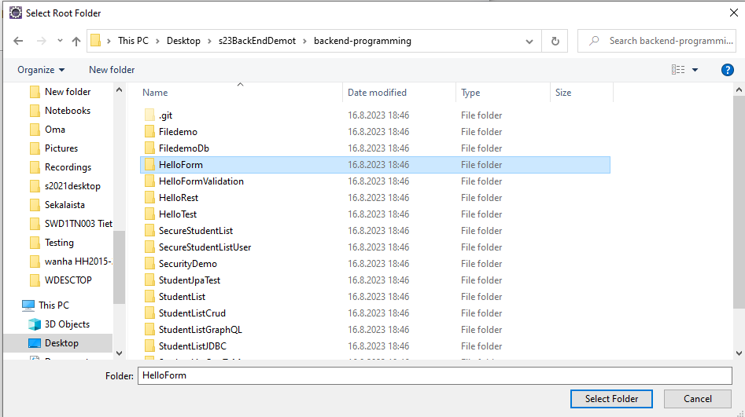
  - And finally, click ‘Finish’ button and the project will be imported to Eclipse (Note! Check that there is pom.xml file). This may take some time.
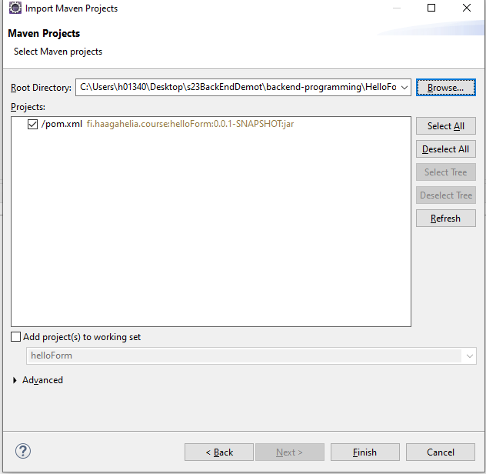
  - After import you should see the following project structure in Eclipse
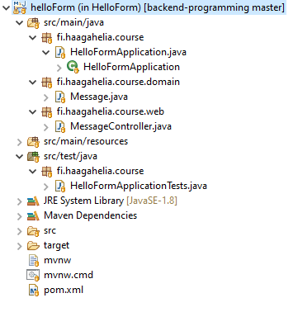
  - Run Spring Boot project class by pressing ‘Run’- button in Eclipse

  - You should see following banner in Eclipse Console

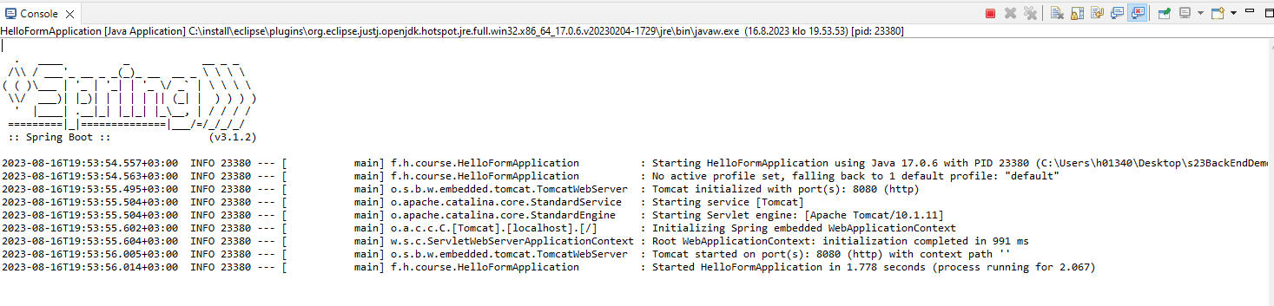

Note! Check endpoint from the controller class For example @RequestMapping(value="/hello", method=RequestMethod.GET)
public String greetingForm(Model model) {
model.addAttribute("message", new Message());
return "hello";
}
You can access your application by browsing to address http://localhost:8080/hello

Repeat same steps to all demos that you want to run.

